SOP – SPM reset procedure in the impact aia.
Process 1 :- Reset procedure done through Jenkins

Step 1:- login to Jenkins url Dashboard [Jenkins] {http://imp-prjumplin01.itc.local:8080/}
Username :- xxxxx
Password:- xxxxx
Step 2:- navigate to dashboard, select the job “SPM_Reset_SBL” as shown below
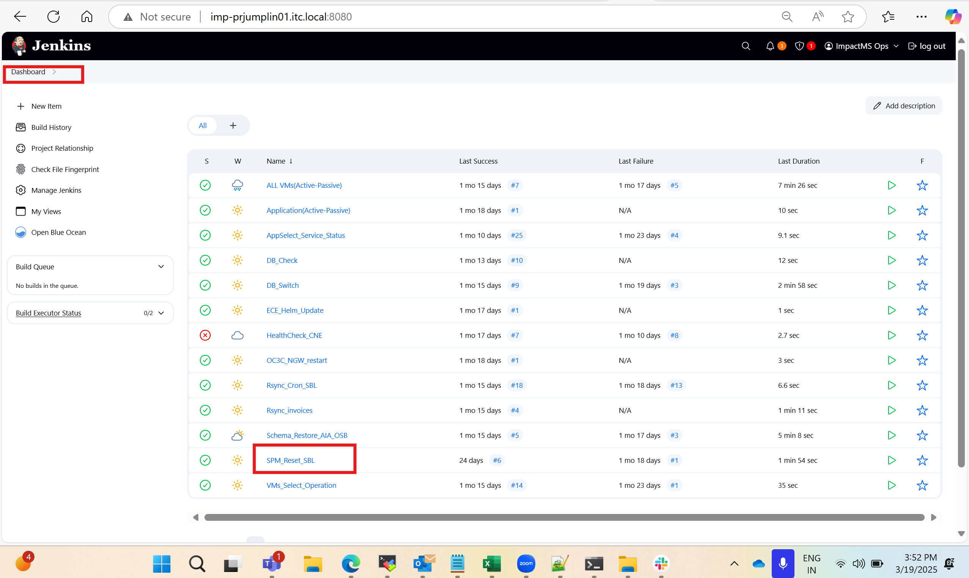
Step 3:- navigate inside the SPM_reset_sbl
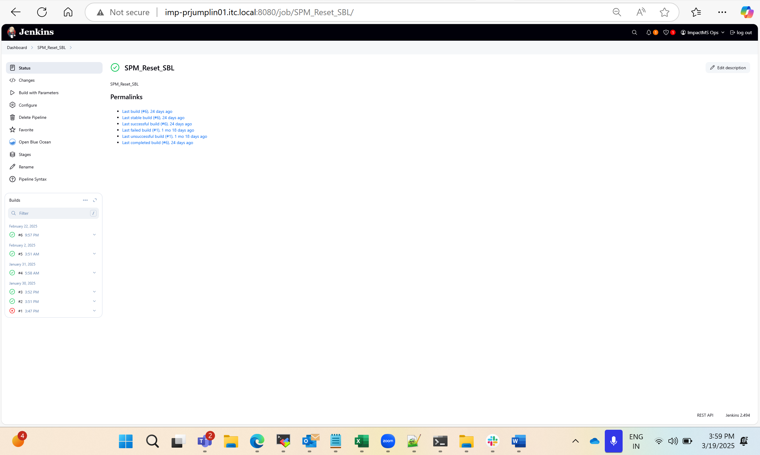
Step 4:- please choose build with parameters
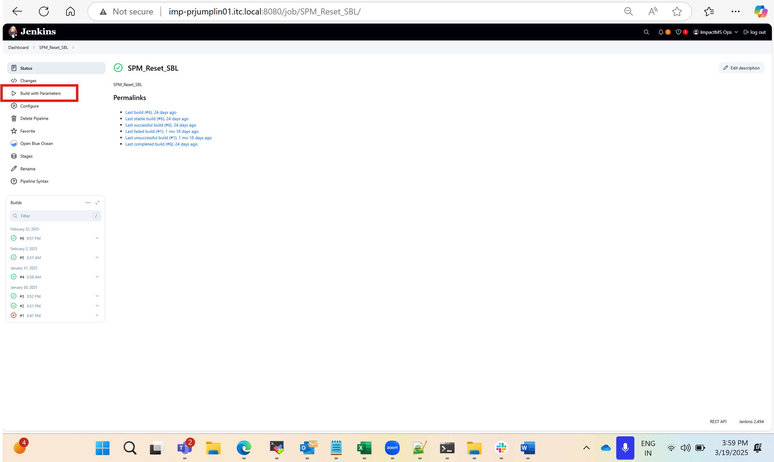
Step 5:- please choose the desired environment against which the reset to be done, is it prod or dr and click Build button.
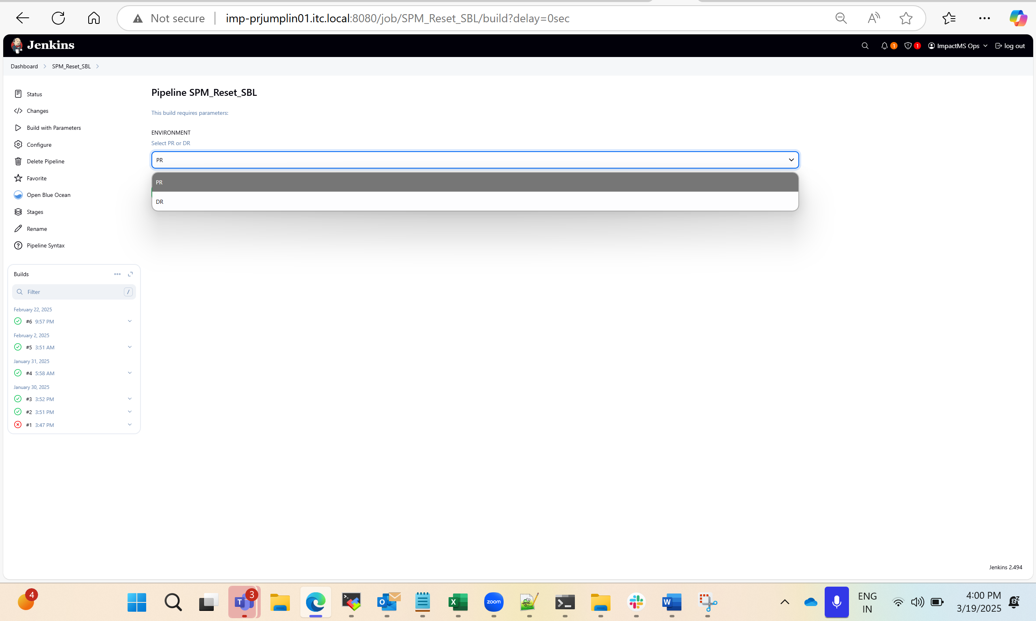
Step 6:- select the last job number and view the console output
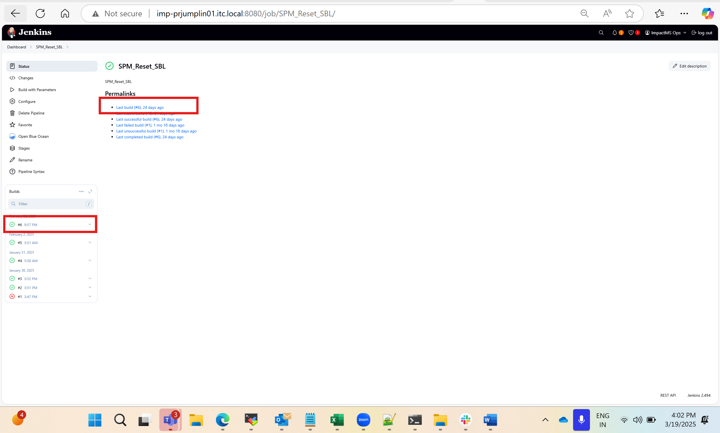
Step 7:- verify the logs for these key terms mentioned below,
SPM reset was completed successfully for: 172.20.10.31 (for all four aia app servers)
SPM reset was completed successfully for all AIA servers
Step 8:- AIA Team must validate and confirm the reset is successful , if this step through Jenkins reset didn’t worked . we need to follow the procedure 2 given below.

Procedure 2:- Manual script execution for doing AIA SPM reset form AIA server 1.

Step 1:- login to the server 172.20.2.28 (AIA Application server 1), switch to Oracle user

Username :- opc and then switch to Oracle user ( su – Oracle)
Password:- xxxxx

Step 2:- navigate to the directory /home/Oracle

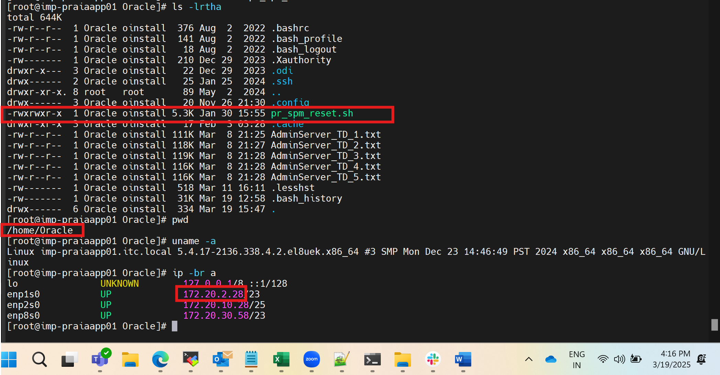

Step 3:-

Execute the script using this command :- ./pr_spm_reset.sh

Step 4: -
Validate the logs and ensure all 4 aia app servers reset completed duly and seen the below messages for all aia app servers

SPM reset was completed successfully for: 172.20.10.31 (for all four aia app servers)
SPM reset was completed successfully for all AIA servers

Please request aia app team to check if all good , if any issues seen, we need to start with procedure 3 .

Procedure 3: SPM reset to be done via the SOAP UI through the Impact RDP (172.20.2.126).

